AI ASSISTED CODING LAB
ASSIGNMENT 1.2
ENROLLMENT NO :2503A51L08
BATCH NO: 19
NAME: BHUKYA RAJESH
TASK1
TASK1 DESCRIPTION:- Write a comment: # Function to check if a string is a valid palindrome (ignoring spaces and case) and allow Copilot to complete it

PROMPT:- Generate a comment: # Function to check if a string is a valid palindrome (ignoring spaces and case) and complete it.
CODE:

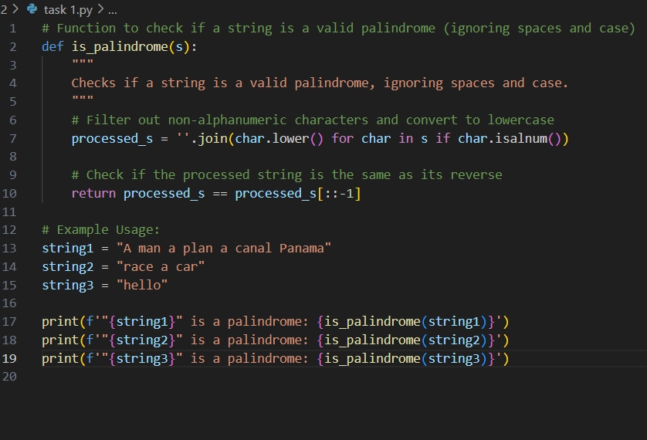

OUTPUT:-
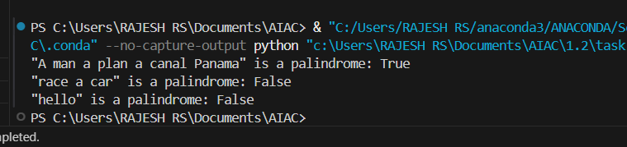

TASK2
TASK1 DESCRIPTION:- Generate a Python function that returns the Fibonacci sequence up to n terms. Prompt with only a function header and docstring

PROMPT:-Generate a Python function that returns the Fibonacci sequence up to n terms. The function should include only the function header and a detailed docstring and should implement with example
CODE:-
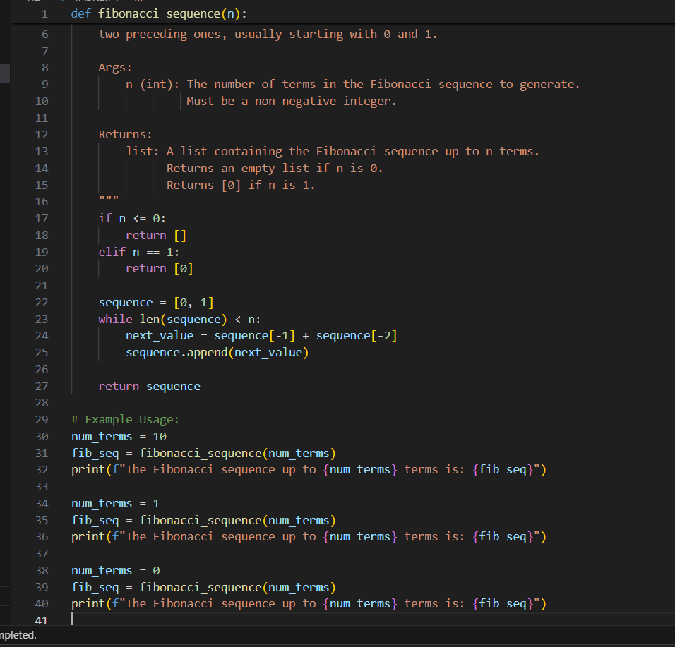
OUTPUT:-
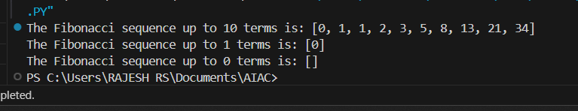

TASK3
TASK3 DESCRIPTION:- Write a comment like # Function to reverse a string and use Copilot to generate the function.

PROMPT:-Write a comment like # Function to reverse a string and generate the
function
CODE:-
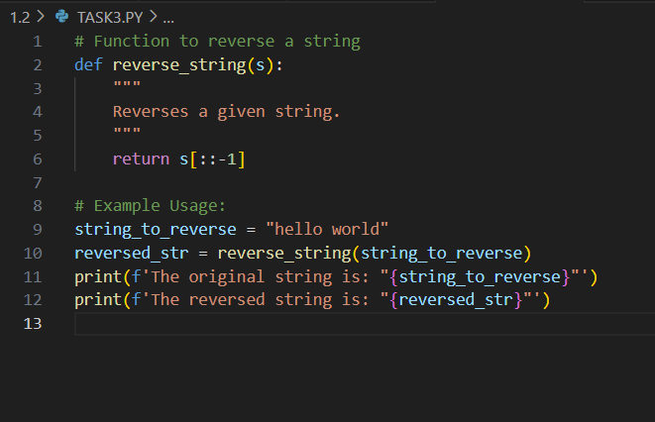
OUTPUT:-
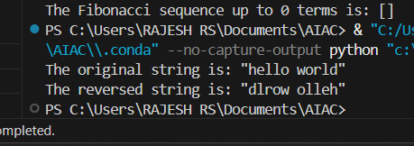

TASK4
TASK4 DESCRIPTION:- Generate a program that simulates a basic calculator (add, subtract, multiply, divide). Write the comment: # Simple calculator with 4 operations and let AI complete it.

PROMPT:-Write the comment: "# Simple calculator with 4 operations" The program should be a fully working calculator with input/output and operator selection logic, supporting add, subtract, multiply, and divide operations.
CODE:-
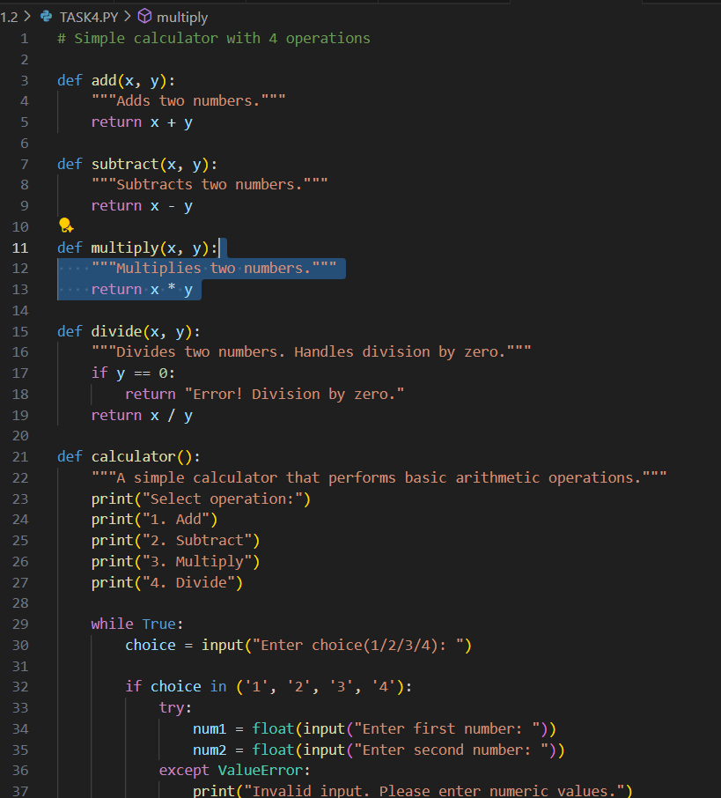

OUTPUT:-
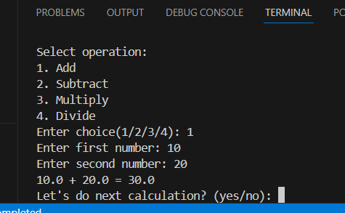

TASK5
TASK5 DESCRIPTION:- Use a comment to instruct AI to write a function that reads a file and returns the number of lines.
PROMPT:- write a function that reads a file and returns the number of lines.

CODE:-
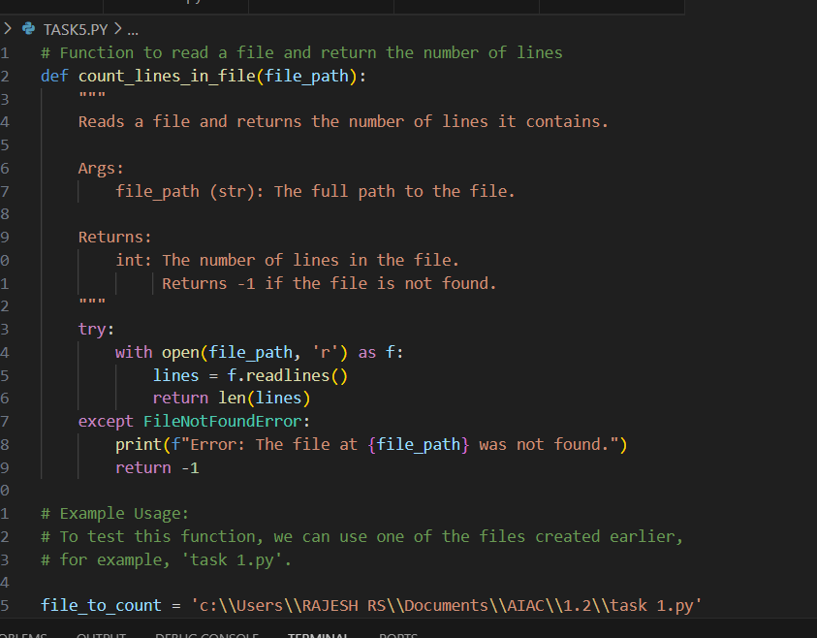
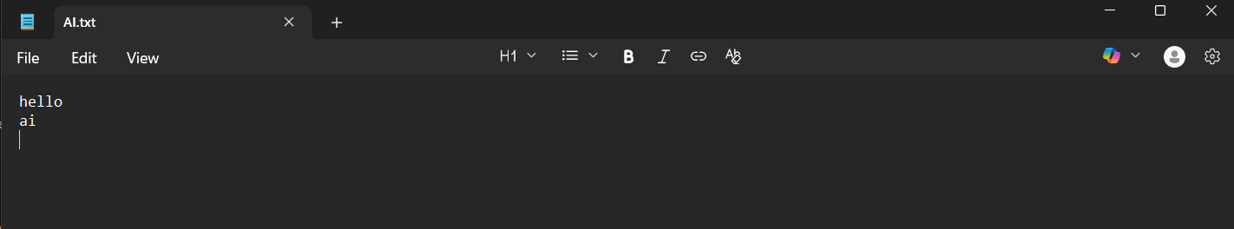
OUTPUT:-
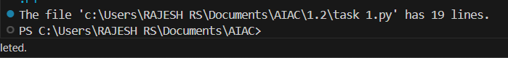

OBSERVATION:- I explored how GitHub Copilot can generate complete and functional Python programs from minimal prompts such as comments, function headers, or docstrings. Each task demonstrated the usefulness of AI-assisted coding in reducing effort, saving time, and improving productivity.
- In Task 1, I observed that a simple comment describing the functionality (checking if a string is a palindrome) was enough for Copilot to generate a correct implementation with case and space handling.
- In Task 2, providing only a function header and docstring for generating the Fibonacci sequence highlighted how Copilot understands documentation and converts it into working logic.
- In Task 3, a short comment about reversing a string allowed Copilot to create a concise and accurate function, showing its ability to handle basic operations efficiently.
- In Task 4, using a comment to describe a “simple calculator with four operations” led Copilot to produce a fully functional program with input handling and operator selection, proving its capability to generate interactive applications.
- In Task 5, Copilot was able to generate file-handling logic from a single comment, showing its usefulness in automating repetitive tasks like counting lines in a file.

